4.3 Counting with Functions
Definition: A function $f:X→Y$ is called n-to-one if every y in the image of the function has exactly n different elements of X that map onto it.
Example: Let $X=\{1,2,3,4,5,6\}$ and let $Y=\{0,1\}$. Define a function $m:X→Y$ by
$m\left(x\right)=\left\{\begin{aligned}0 if x is odd \\ 1 if x is even\end{aligned}\right\}$. This function is three-to-one, because there are three numbers that map to 0 and three numbers that map to 1.
Theorem 4.6: Let |X| = p and |Y| = q. If there is an n-to-one function $f:X→Y$ that maps X onto Y, then p=qn.
Example 1: A group of 10 people sits in a circle around a campfire. How many different seating arrangements are there? In this situation, a seating arrangement is determined by who sits next to whom, not by where on the ground they sit. Let's also agree not to distinguish between clockwise and counterclockwise; all that matters is who your two neighbors are, not who is on your left and who is on your right.
In order to solve this problem, we have to think of this as an n-to-one function. So let's start with a simpler question: What if we lined up the 10 people in a row instead of a circle? In that situation, it's easy to figure out how many ways to arrange that: $P\left(10,10\right)$. As we saw in 4.2, there's distinct elements and the order matters, so we're using a permutation.
Next, let's think of a function, we'll call it f, that when you plug in a row of people, it rolls it into a circle of people to sit around the campfire. So $f:X→Y$ where X is the set of rows of 10 people and Y is the set of circles of 10 people. If we can figure out the "n" for this n-to-one function, then we can find the answer to our question.
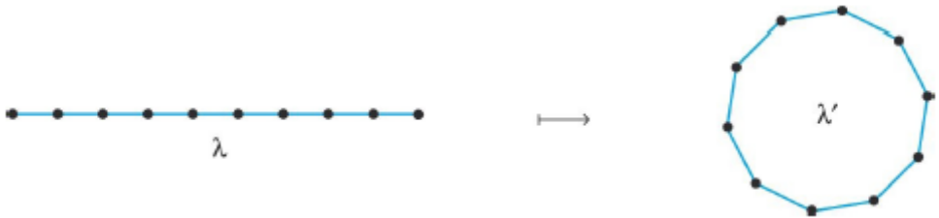
To find n, we have to answer the question, "How many different circles can one line of people make?"
So here's where the math comes back in. Look at the circle and see how many places you can cut it to unroll it into a line.
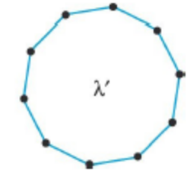
There appears to be 10 places I can cut the circle. If I cut it at one of these black lines and unroll it, it would be one of my elements of the set X.
BUT, I could unroll it clockwise or counterclockwise, which would make two different rows. So I need to double my number from 10 to 20.
So this is a 20-to-one function.
To get our final answer, we take the number of rows and divide it by 20. So $\frac{P(10,10)}{20}=181,440$ different ways to sit around in a circle.

At this point, you might be worried that this problem is very complicated and "How will I ever solve these?!!" Well, here's a short summary of the steps to help you with the homework. We'll work through number 21 in the back of this section. If you can do that one, they all work the same way.
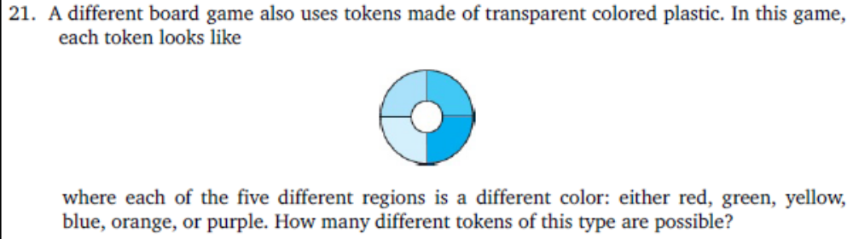
Step 1: If we unroll this into a row, how many ways can we color it? Well, this has 6 colors to fill in 5 spaces, so $P\left(6,5\right)=720$.
Step 2: How many places can I cut it to unroll it? There are 4 seams, so 4. (Top, Left, Bottom, Right).
Step 3: Double the number from step 2 to account for clockwise and counterclockwise. $4∙2=8$
Step 4: Divide! $\frac{720}{8}=90$. And that's the answer!

The Pigeonhole Principle
Theorem 4.7: Let $X$ be a set with n elements, $Y$ be a set with r elements and let $f:X→Y$. If $n>r$, then there are distinct elements $x,y∈X$ such that $f\left(x\right)=f(y)$.
So if there's more elements in your domain than your codomain, then some of the elements in your domain must map to the same element in your codomain.
Example 2: In a club of 400 members, must there be some pair of members who share the same birthday?
Yes. Since there are 400 people but only 365 days, there are at least two people with the same birthday.

Example 3: Chandra has a drawer full of 12 red and 14 green socks. In order to avoid waking his roommate, he must grab a selection of socks in the dark and get dressed in the hallway. How many socks must Chandra grab to be assured of having a matching pair?
Since there are 2 colors of socks, we need more than 2 in order to guarantee a matching pair. So he must grab at least 3 socks.

HOMEWORK: #10-13, 19, 20, 21, 23, 26, 28, 30

